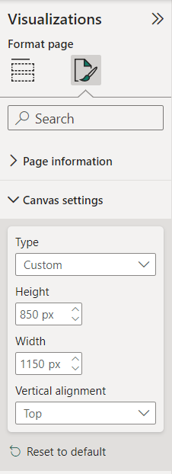

­­­­

CUSTOMER COUNT

CHURN RATE

